**Ganpat University**

**Faculty of Engineering & Technology**

**Computer Science & Engineering**

**(2CSE204) Basics of Operating System and Shell Scripting**

***Name:- Dwij Vatsal Desai***

***Sem:- 2***

***Enrollment No.:- 23162121027***

***Date:- 26/3/2024***

**CO Practical exam**

1. 6-bit subtracter  
   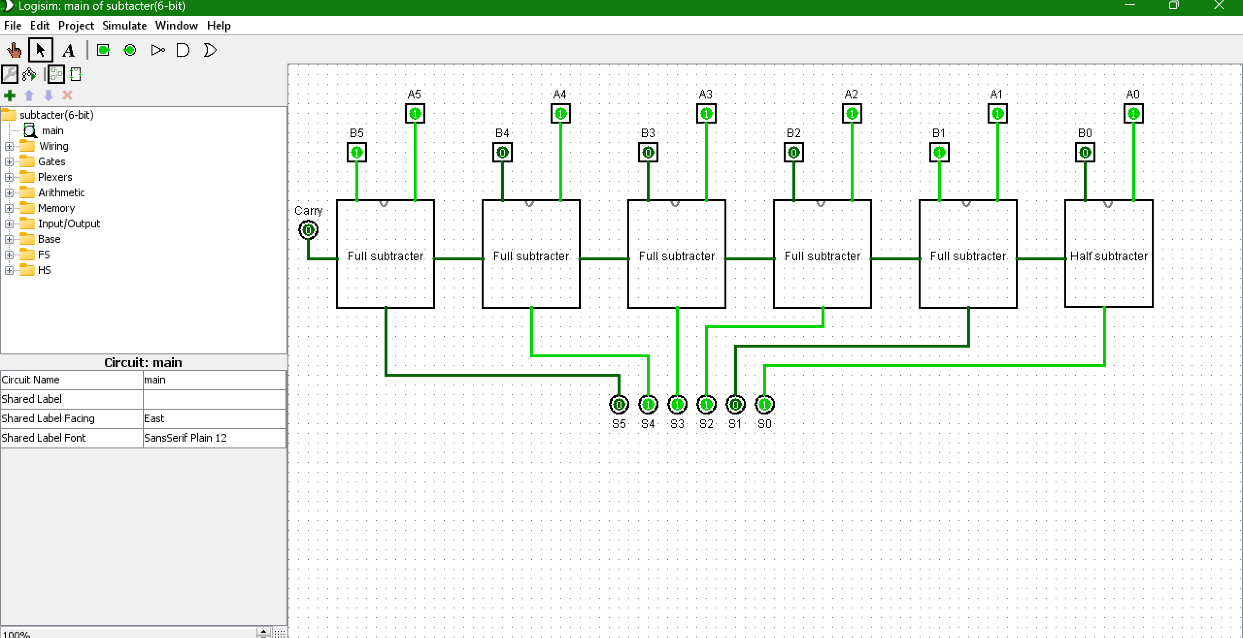

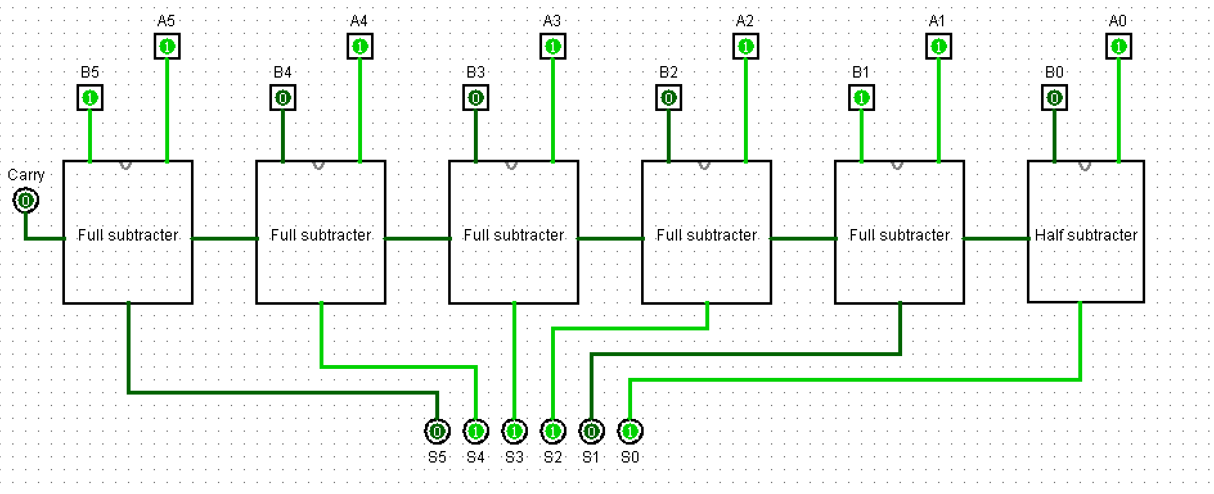

1. 6-bit subtracter(using Full adder)

